A1341-ME-Canaanite Bronze Deity, Late Bronze Age-1550-1200 BCE

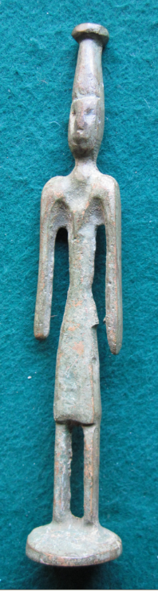 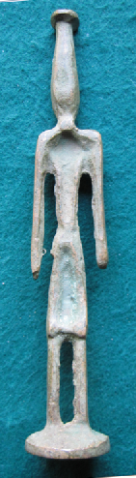 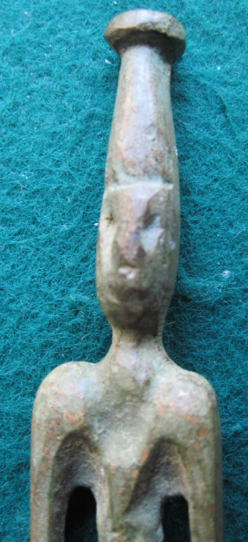

Figs. 1-3. Canaanite Bronze Deity, Late Bronze Age 1550-1200 BCE

**Case no.:**

**Accession Number:**

**Formal Label:** Canaanite Bronze Deity, Late Bronze Age 1550-1200 BCE

**Display Description:**

**LC Classification:**

**Date or Time Horizon:**

**Geographical Area:**

**Map, GPS coordinates:**

**Cultural Affiliation:**

**Media:** **Dimensions:**

**Weight:**

**Condition:**

**Provenance:**

**Discussion:**

**References:**

A

A statuette of Canaanite bronze deity. Solid-cast, standing with his feet together, both arms bent at the elbow, the right arm likely was raised, the lower projecting forward, both hands fisted around now-missing weapons and attributes, wearing a conical headpiece and possibly a short-sleeved V-necked garment, the broad belt with a vertical tab descending to the hem in front, his face with large almond-shaped eyes defined by incision, a prominent nose, protruding lips and a pointed chin, his ears perforated, a large tenon below the feet. The deity depicted is likely Baal who was often depicted in this pose, with a raised right arm.

The god Baal embodied royal power and authority. Much of our knowledge about Canaanite gods comes from the local Canaanite literature, particularly from the archive of cuneiform tablets from the site of Ugarit. The Canaanite gods and goddesses continued to be worshipped during the first millennium BC, though some of their functions changed. They were worshipped wherever the Canaanites established trading colonies across the Mediterranean. (source: The British Museum)

Item cleaned, waxed and solidified professionally. Coarse surface, metal layering in places. Arms broken off.

Condition: Poor

*Period:* Reference: Christie's sale 1561, lot 144, sale 3403, lot 81.